TFS #92356

Allow purchased participation loans to be secured by chattel.

Overview

LT loans that are purchased participations need to be exempt from the exclusion of chattel. Chattel collateral can be security for LT purchased participations so they need to be treated differently.

April Beston

09/30/2016

Table of Contents

TFS # 1

Description 2

Testing Notes 2

Screen Shots and Steps Taken 2

# Description

BCM 8/5/16 - Original Request: "LT loans that are purchased participations need to be exempt from this exclusion. Chattel collateral can be security for LT purchased participations so they need to be treated differently."

FPI Notes/Examples: LT loans are secured by Real Estate in 1st position. Participation loans get booked in LT portfolio and are secured by chattel, because are tax exempt. HOWEVER, Participation loans are not really Long Term loans. Can we do something with what type of loan it is?

 RJM 8/8/2016 -

#42 on Collateral Web Enhancement List

From Bob's comments to EPC:

Rationalization: Incorrect calculations are flowing to MR etc.

Designed Solution: Fix the calc to include chattel for LT Part Purch Loans

RJM Testing notes 8/16/16 -

FCW does not have the AssocParm (806- LTExcludeSTAndChattelInd) to ignore chattel for LT loans turned on, so you can secure LT loans with chattel for FCW.

We should test to make sure FCW behaves as expected.

We should also test against Yankee or FCE to make sure the change is actually implemented.

RJM 8/24/16 - Email thread with Steve Rickenbacher attached discussing participation loans and sharing collateral  with ST loans.

AMB 10/3/16 - Test passed: For FCE and Yankee, LT Particpation loans can be secured with chattel, and calculations behave as expected. For FCW, both standard and participation LT loans include chattel in calculations properly.

See: <https://extranet.financialpartners.com/Workspaces/Shared/cwenhance/FPIDocuments/2016%20Q4%20TFS%20Testing%20Docs/Ability%20to%20Edit%20Loan%20Position%20from%20Collateral%20Analysis%20Screen.wmv>

# Testing Notes

Test to make sure chattel is included in calculations for LT participation loans for FCE & YKE. For FCW, test to make sure calculations behave as expected for participation and non-particpation LT loans.

Test passed: For FCE and Yankee, LT Particpation loans can be secured with chattel, and calculations behave as expected. For FCW, both standard and participation LT loans include chattel in calculations properly.

See: [**https://extranet.financialpartners.com/Workspaces/Shared/cwenhance/FPIDocuments/2016%20Q4%20TFS%20Testing%20Docs/Ability%20to%20Edit%20Loan%20Position%20from%20Collateral%20Analysis%20Screen.wmv**](https://extranet.financialpartners.com/Workspaces/Shared/cwenhance/FPIDocuments/2016%20Q4%20TFS%20Testing%20Docs/Ability%20to%20Edit%20Loan%20Position%20from%20Collateral%20Analysis%20Screen.wmv)

## Screen Shots and Steps Taken

Insert a security agreement and collateral, then link to one or more long term Particpation loan(s).

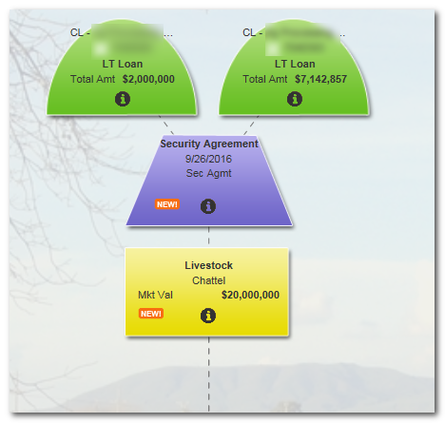

Then navigate to the Quick Loan Analysis” screen on the collateral view, or to the Collateral Analysis tab. In either case loan to value calculations will not be 0% because chattel is included in the calculations.

Quick Loan Analysis –

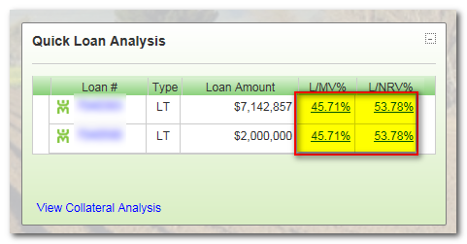

Collateral Analysis Screen –

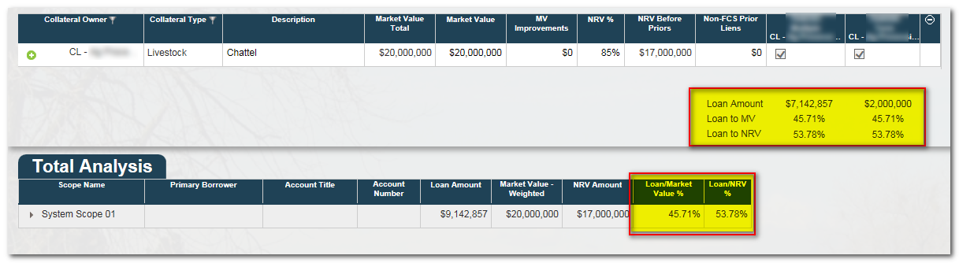

**Note:** On the Collateral Analysis screen you can also verify that individual collateral is being used in calcualtions if the “Market Value – Weighted” and “NRV Amount” are not $0 in the Total Analysis grid:

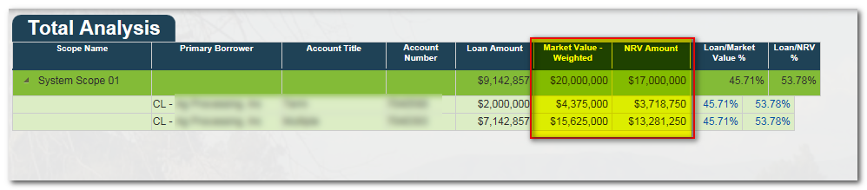

I also tested to make sure standard LT Loans were not impacted by this change, and still excluded collateral.

In this example it can be seen that chattel has been linked to a stand LT loan:

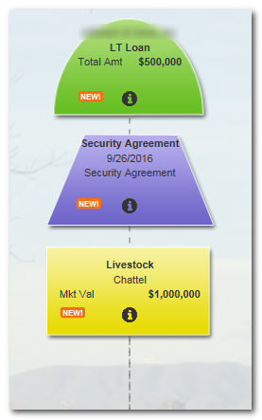

In contrast to the LT participation loan, it can be seen that the chattel in this scenario is NOT included in the loan to value calculations.

This is the Quick Loan Analysis for this scenario:

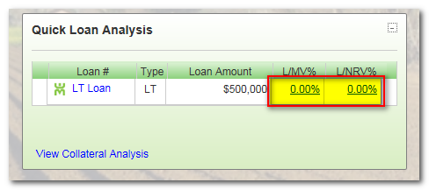

and the Collateral Analysis tab:

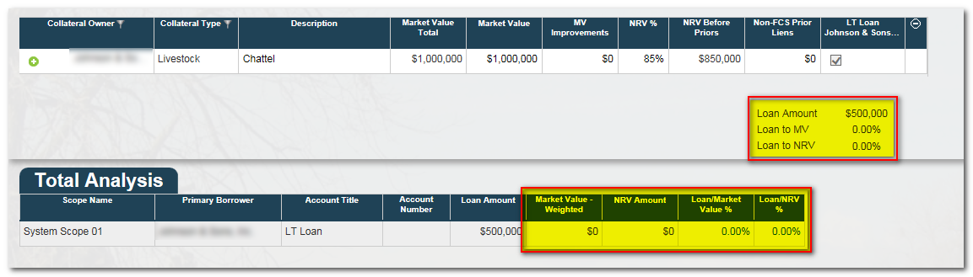

For FCW I tested to ensure that chattel behaves as expected. FCW has no restriction on the use of chattel as collateral for LT loans. Consequently, LT loans are included in loan to value calculations for LT participation and non-particpations loans. This is an example of a standard LT loan:

